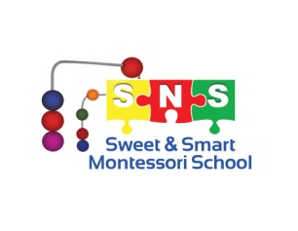
SUMMER CAMP 2023
During our summer program we will include Montessori lessons, this is what we call “The Montessori taste”. Kids will do their lessons as the normal workshops, but in a shorter time, compared to regular School year. Every day we will do crafts or projects related to their session and on Fridays they will take them home and share them with you!
Also, remember that every Friday we will have water day (if the weather permits). Don’t forget to pack: extra clothes, sunscreen, towel, and bathing suits!!! We can’t wait for summer and start having fun!!!!
Please check, each session you want to attend

- SESSION 1
Jun 12th - Jun 16th
Art Galaxy
Spark your imagination and engineer a recycled robot, construct a futuristic android and paint a surrealistic landscape where dreams become reality
- SESSION 2
Jun 19th - Jun 23rd
Transportation Week: We will ride on different types of transportation and why not make your own? .

- SESSION 3
Jun 26th - Jun 30th
Sports Week: get ready to cheer for your favorite team, while playing your favorite sport.
- SESSION 4
Jul 3rd – July 7th
Cooking and USA Party Let’s sing Happy Birthday to America, and travel all around.

- SESSION 5
Jul 10th - Jul 14th
Adventure Land Week: Who do you like best: super heroes, princesses, or pirates? Come and dress up as your favorite one!

- SESSION 6
Jul 17th - Jul 21st
Animal Week: Where does the Panda live? Do you want to learn about animals and enjoy a visit from some animals??
- SESSION 7
Jul 24th - Jul 28th
Arts and Craft Week: Lets do lots of crafts and learn about Art. WE will get Messy and colorful
- SESSION 8
Jul 31st -Aug 4th
Farm week: we will learn about the farm and pretend to be farmers, get ready to play with some farm animals

- SESSION 9
Aug 7th – Aug 11th
Water Week: All we need for summer: a whole week of splash and ice pops!! We are ready to get wet all day

- We will be open from regular hours
- June 18th we will celebrate Father's Day
- School will be closed on July 4th Happy Independence day
- School will be closed the week of Aug 14th - Aug 19th
- First day of School will be Aug 21st.
- Name of your Child: ____________________________________________________

